***AWS PROJECT REPORT***

***Title*** : Create a Php Website OF GLA university and Host it on Aws EC2 instance.

**GROUP :- 18**

* Govind Sharma
* Harsit Gargacharya
* Sanskriti Sharma
* Poonam Saraswat
* Saumya Chahar

*Components Used :-*

* AWS EC2 instance –

**Amazon Elastic Compute Cloud** (**EC2**) is a part of [Amazon.com](https://en.wikipedia.org/wiki/Amazon.com)'s [cloud-computing](https://en.wikipedia.org/wiki/Cloud-computing) platform, [Amazon Web Services](https://en.wikipedia.org/wiki/Amazon_Web_Services) (AWS), that allows users to rent [virtual computers](https://en.wikipedia.org/wiki/Virtual_computer) on which to run their own computer applications. EC2 encourages scalable deployment of applications by providing a [web service](https://en.wikipedia.org/wiki/Web_service) through which a user can boot an [Amazon Machine Image](https://en.wikipedia.org/wiki/Amazon_Machine_Image) (AMI) to configure a [virtual machine](https://en.wikipedia.org/wiki/Virtual_Machine), which Amazon calls an "instance", containing any software desired. A user can create, launch, and terminate [server](https://en.wikipedia.org/wiki/Server_(computing))-instances as needed, paying by the second for active servers – hence the term "elastic".

* Mysql-

mysql is used to create a database for the users who enters their details for admission related queries and the database. The user details will shown in the form of table inside the database.

* HTML,CSS and JAVASCRIPT-

The all three programming languages are used to provide the interface for the GLA university website.

The HTML provide all required options in the clone and the CSS and JAVASCRIPT provides the design and insertion of images and multimedia..

* PHP programming Language –

The php language is used to Connect the backend and frontend part with the database. It contains the source code from HTML and be avail for the server to host. PHP code is usually processed on a [web server](https://en.wikipedia.org/wiki/Web_server) by a PHP [interpreter](https://en.wikipedia.org/wiki/Interpreter_(computing)) implemented as a [module](https://en.wikipedia.org/wiki/Plugin_(computing)), a [daemon](https://en.wikipedia.org/wiki/Daemon_(computing)) or a [Common Gateway Interface](https://en.wikipedia.org/wiki/Common_Gateway_Interface) (CGI) executable. On a web server, the result of the [interpreted](https://en.wikipedia.org/wiki/Interpreter_(computing)) and executed PHP code—which may be any type of data, such as generated [HTML](https://en.wikipedia.org/wiki/HTML) or [binary](https://en.wikipedia.org/wiki/Binary_number) image data—would form the whole or part of an [HTTP](https://en.wikipedia.org/wiki/HTTP) response.

***Procedure :–***

**1.Open the aws console and login with your account and select the ec2 option from search bar.**

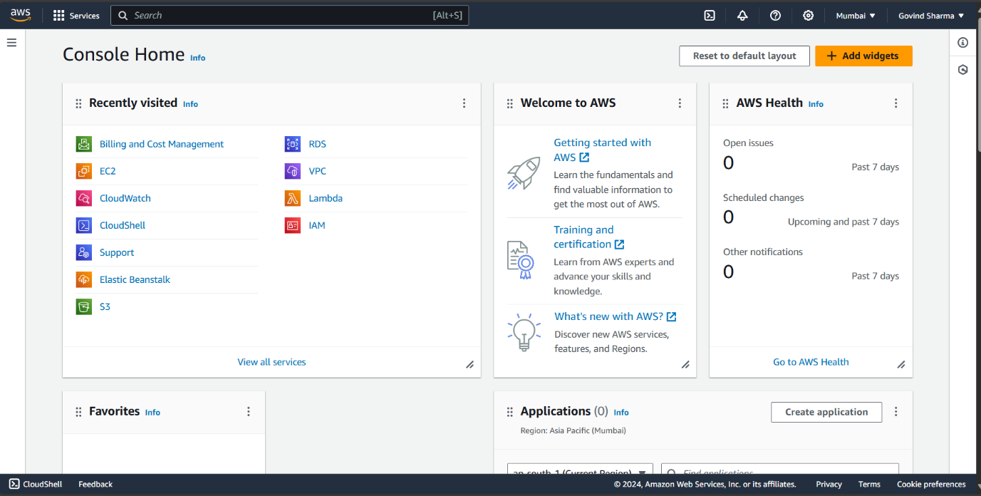

**2.Now select the launch instance option.**

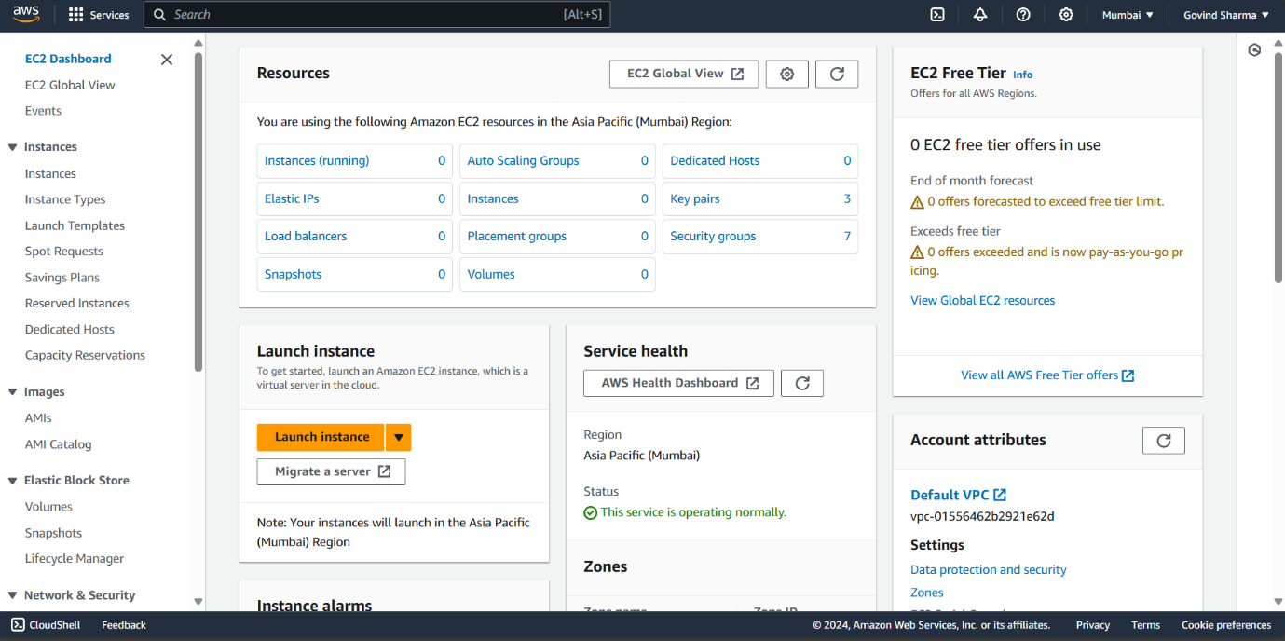

**3.Name the server as Gla university.**

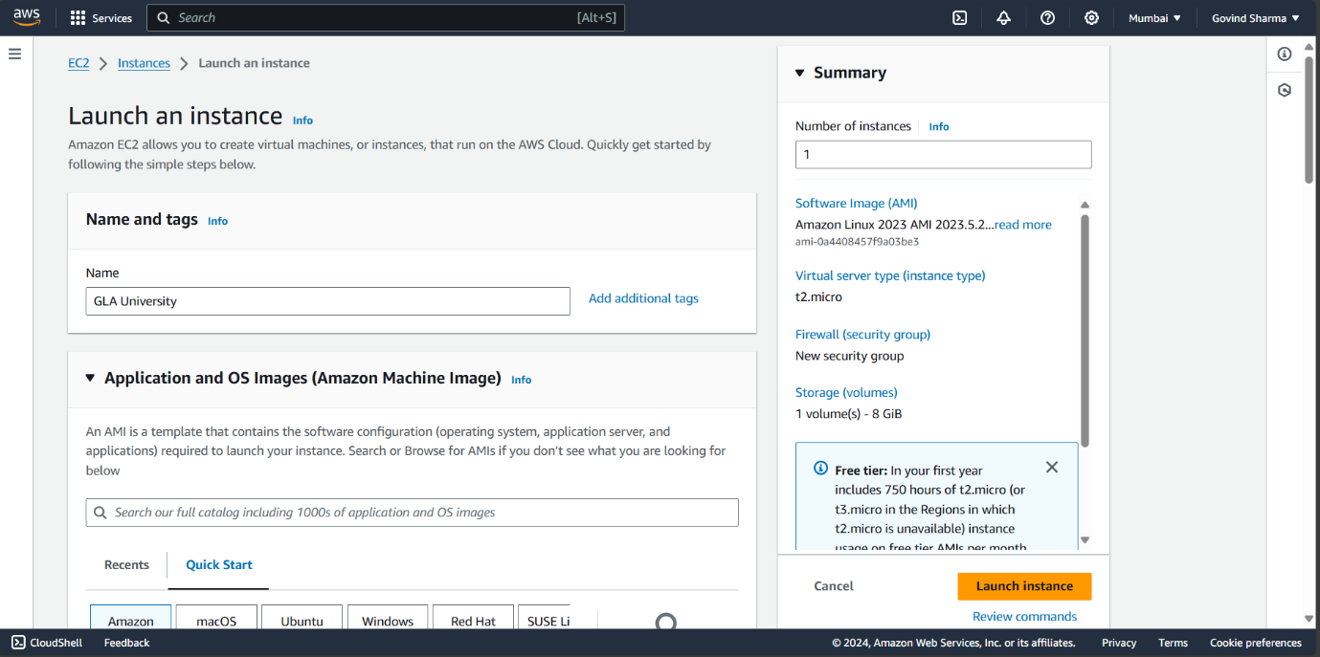

**4.Now select the operating system as windows with AMI version Microsoft Windows server 2022 Base.**

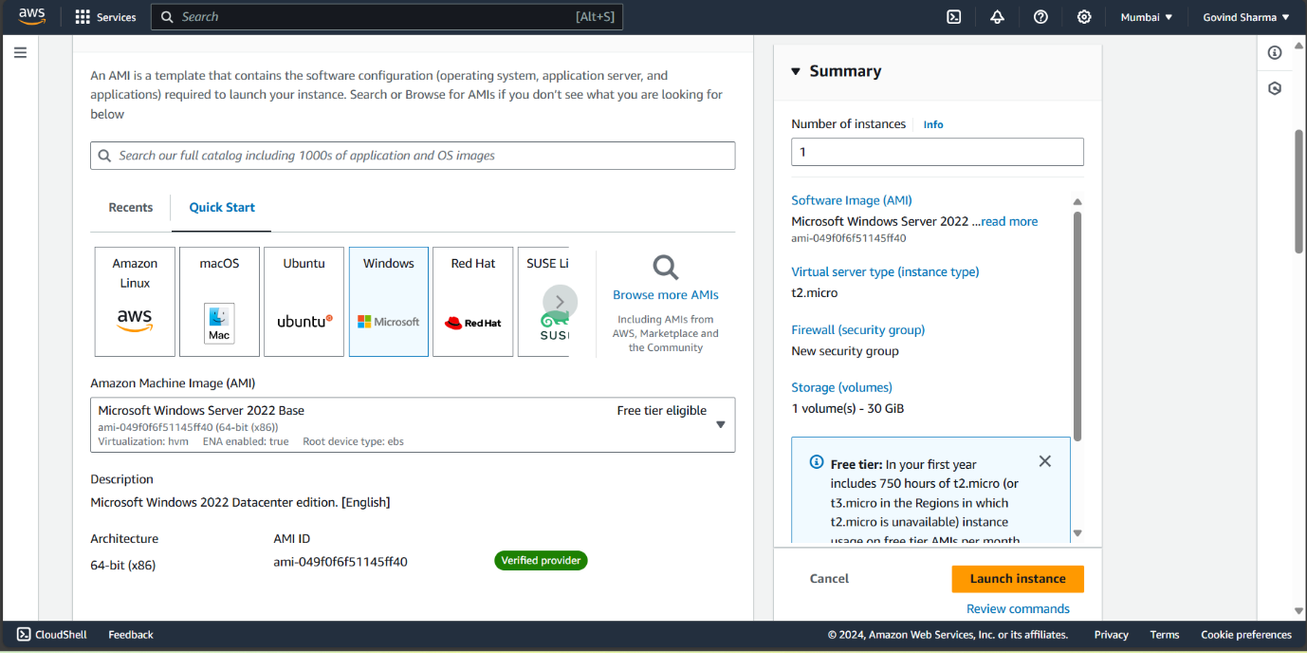

**5.The AMI version of Windows 2022 auto selects instance type as t2 micro which is a free tier instance.**

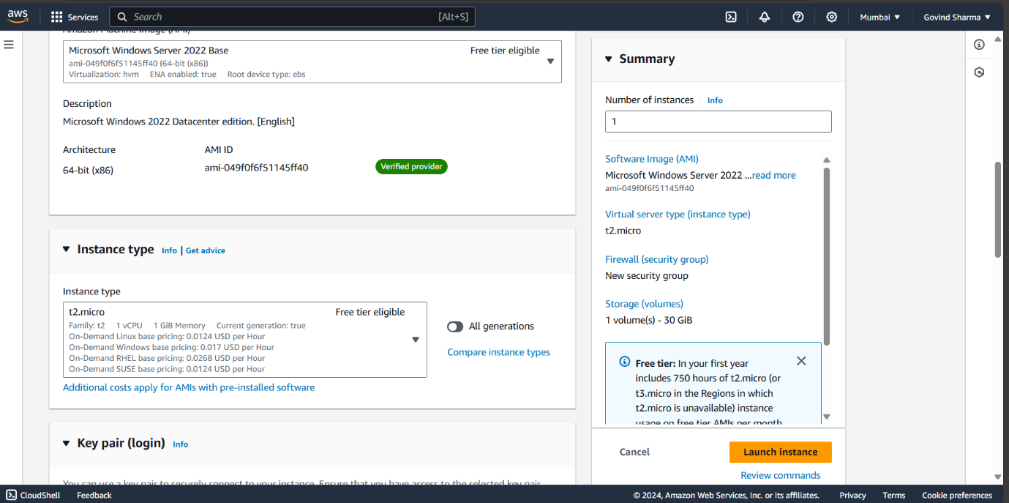

**6.Now select new key pair option and named it as glakeypair.**

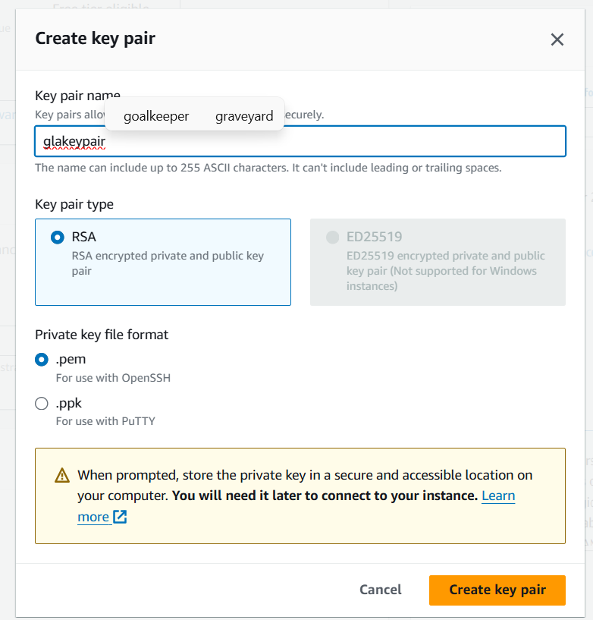

**7.Now key pair is created .**

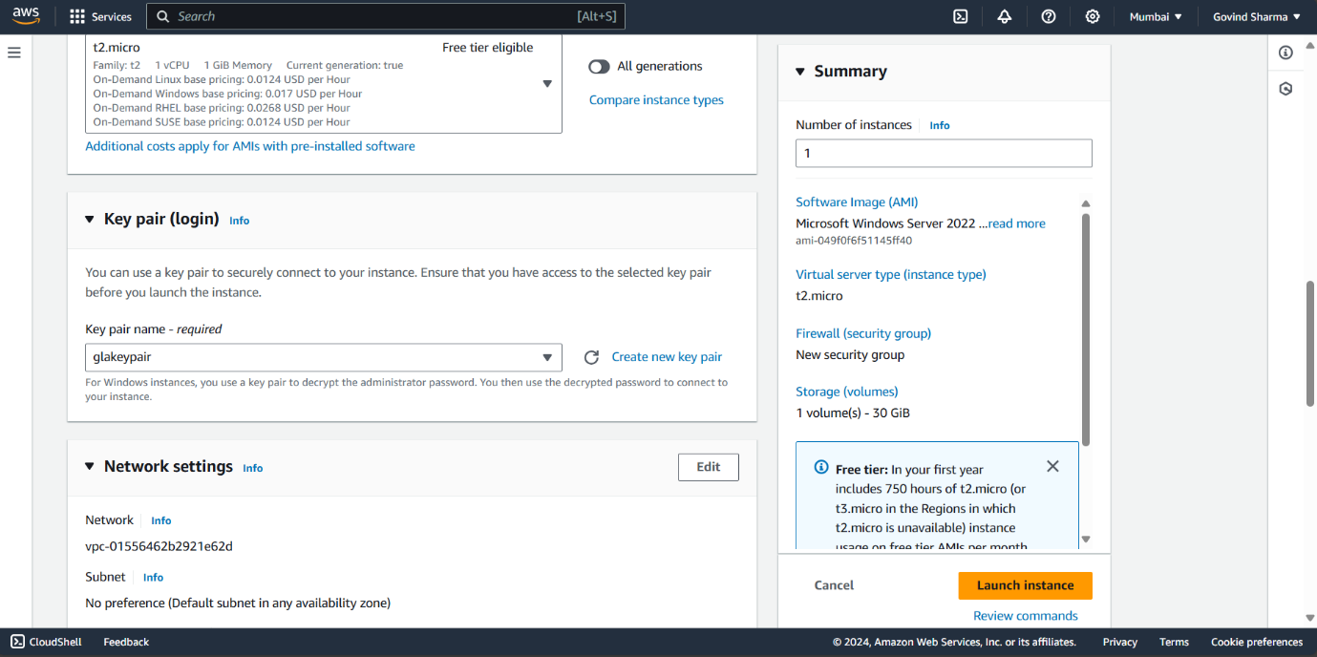

**8.Now for network setting make the selection as mentioned below.**

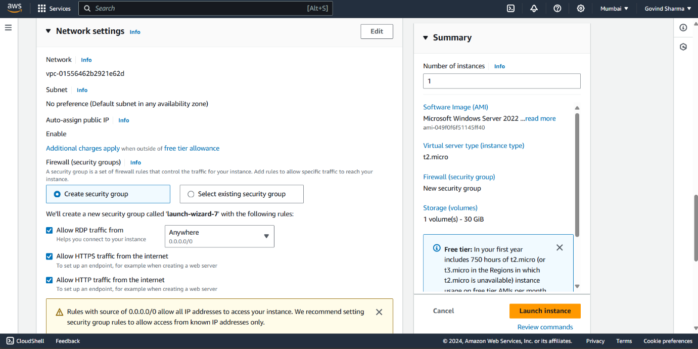

**9.Now we can launch the instance by clicking on launch instance option.**

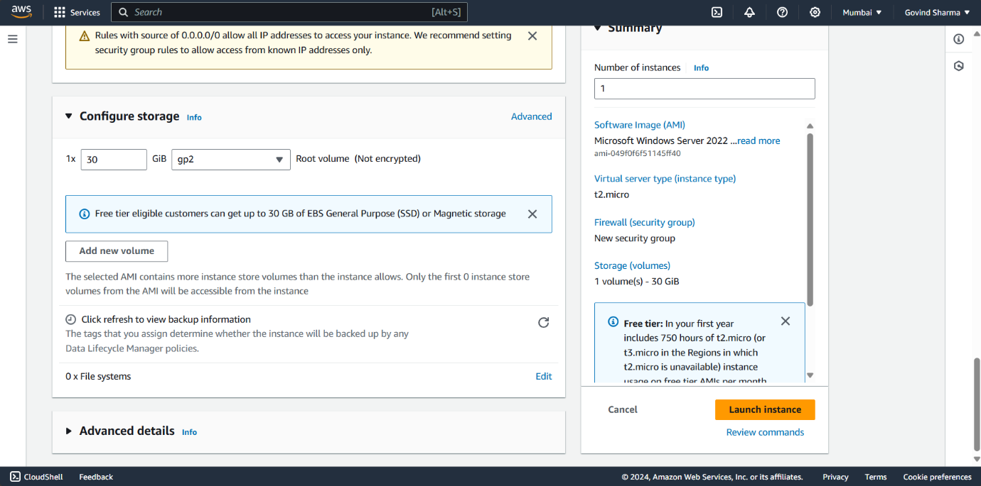

**10.Now wait until the server gets ready.**

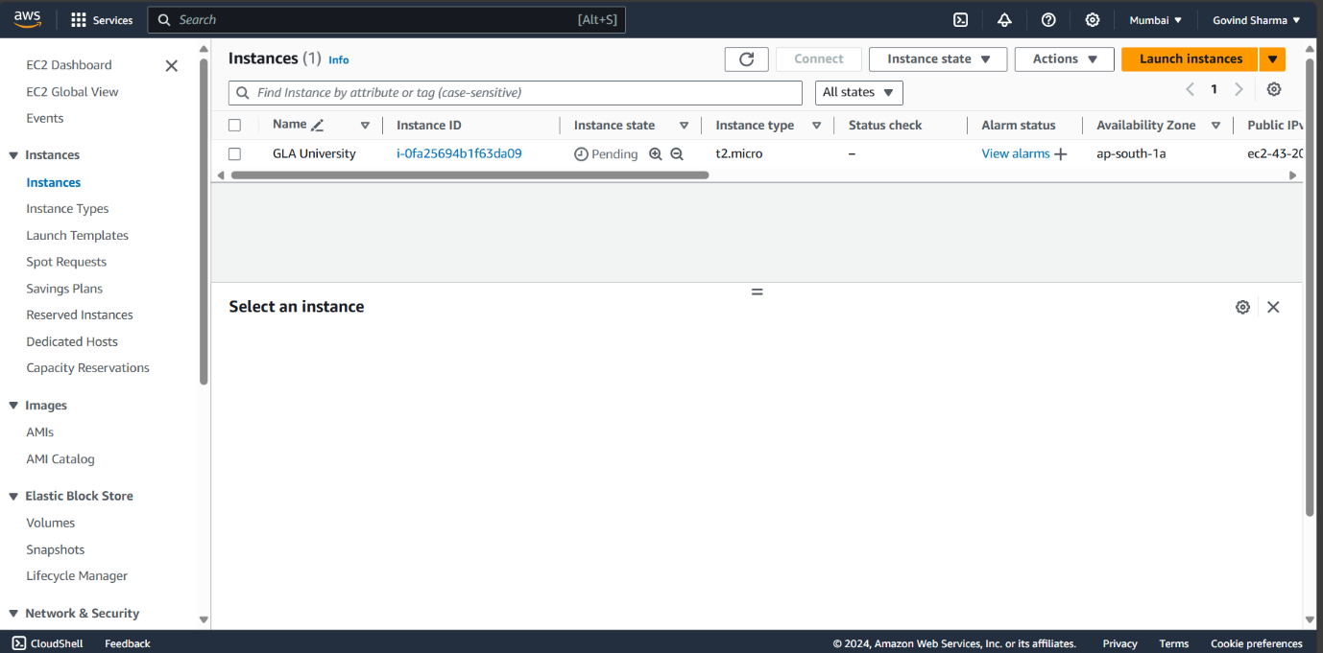

**11.Now select the instance and click on connect option.**

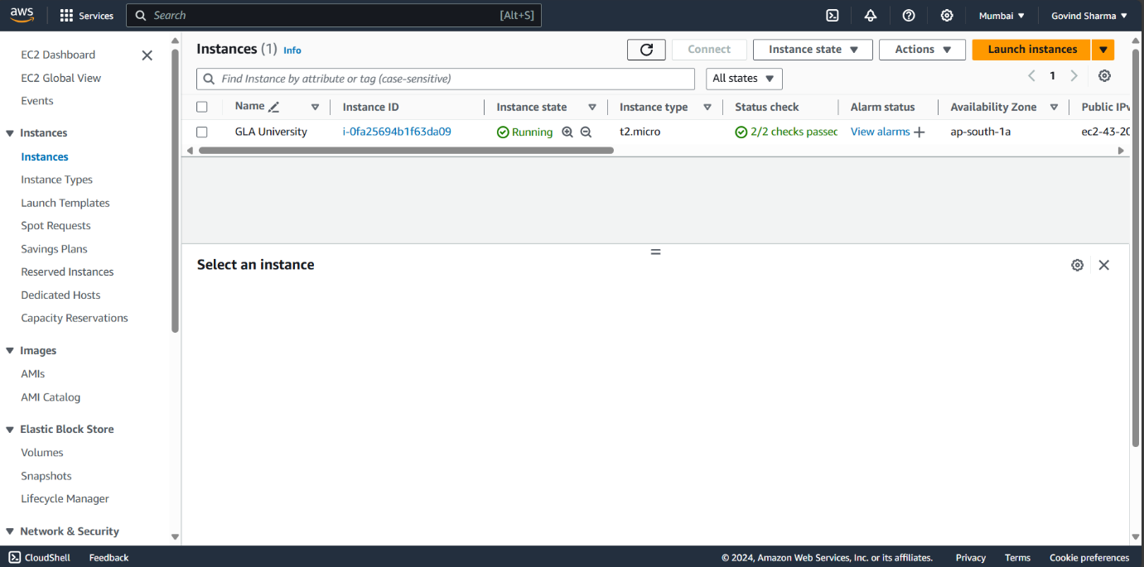

**12.Now select RDP client and download the remote desktop file.**

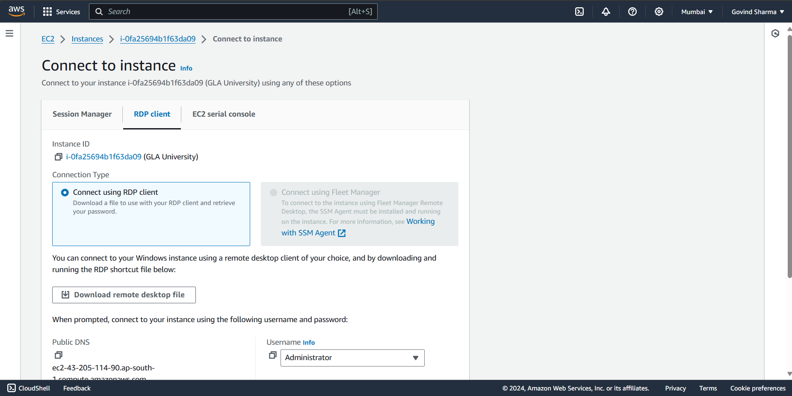

**13.Now select get password option and upload the private key file which was created earlier named as glakeypair and decrypt.**

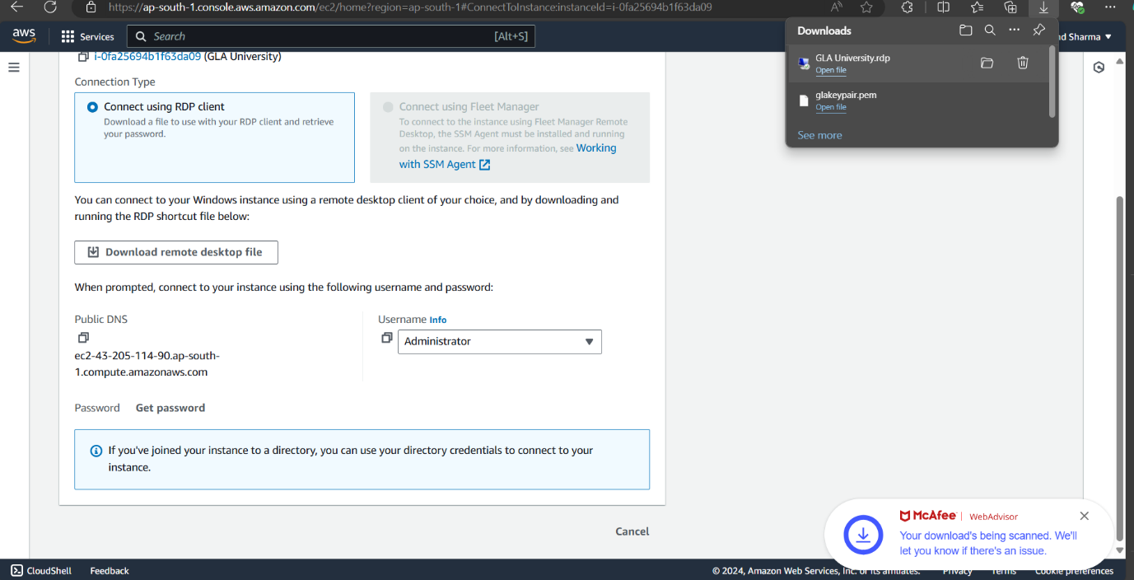

**14.The decrypted password shown below the password option copy it.**

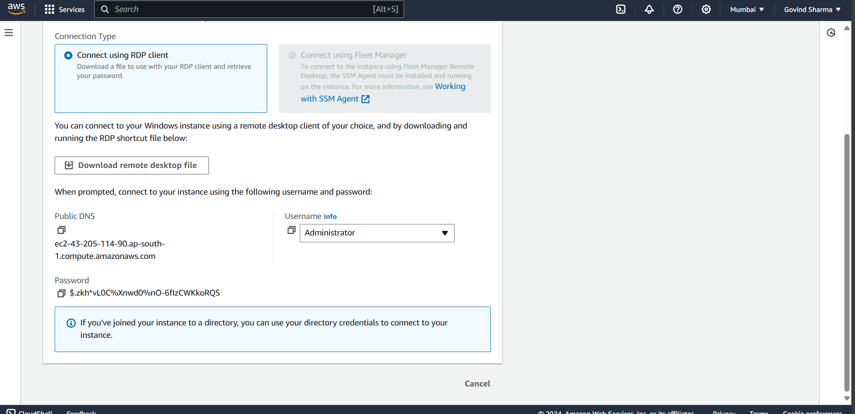

**15.paste the password on notepad as it would be used to access the remote desktop**

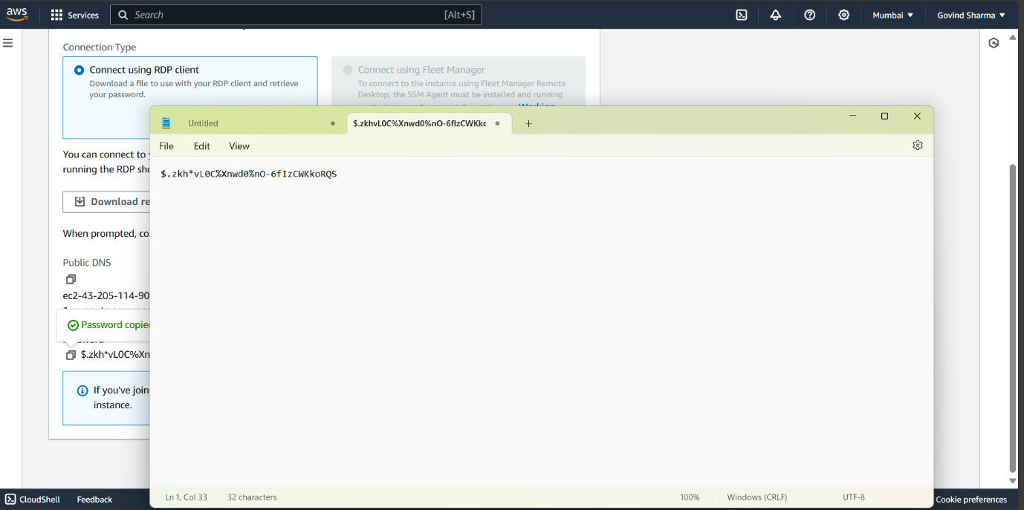

**16.Now open the remote desktop file and open it.**

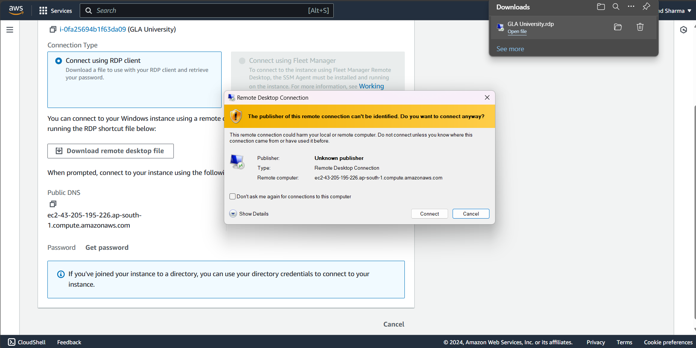

**17. Enter the password and which was paste on notepad and click Ok.**

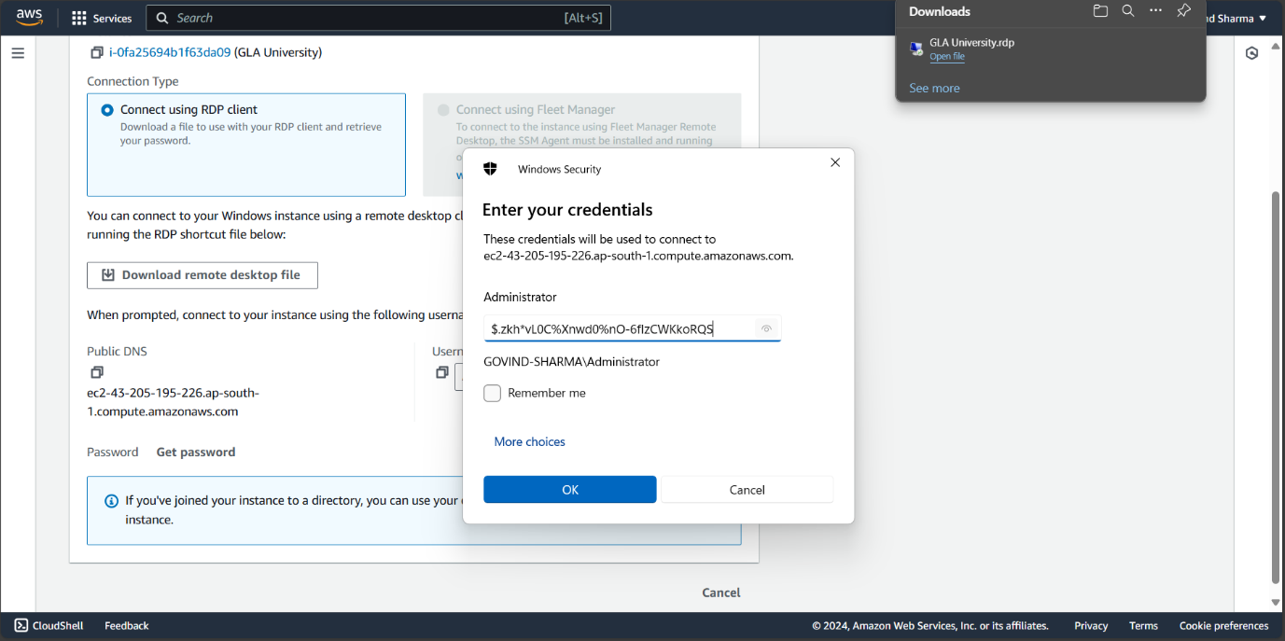

**18.Click Yes , the remote desktop connection will start connecting.**

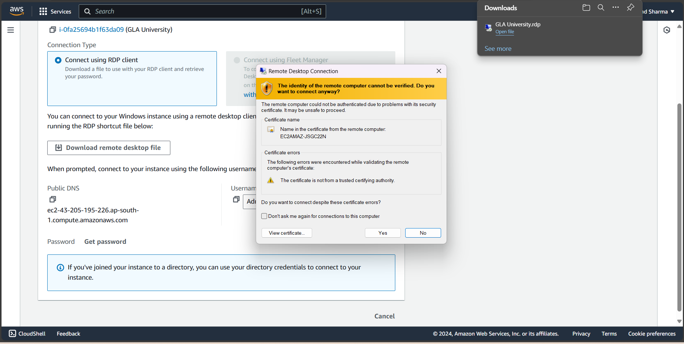

**19. The windows shows the dashboard with the details of connection the top right corner.**

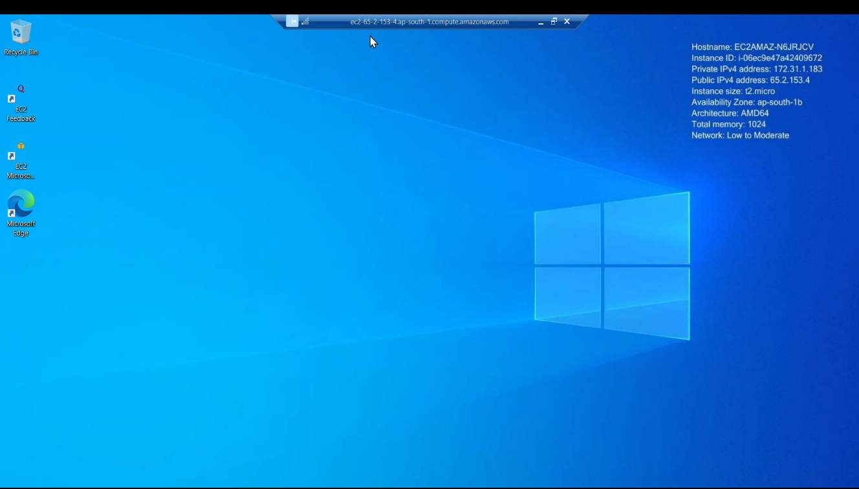

**20. Search Window security in search bar and select firewall and network protection.**

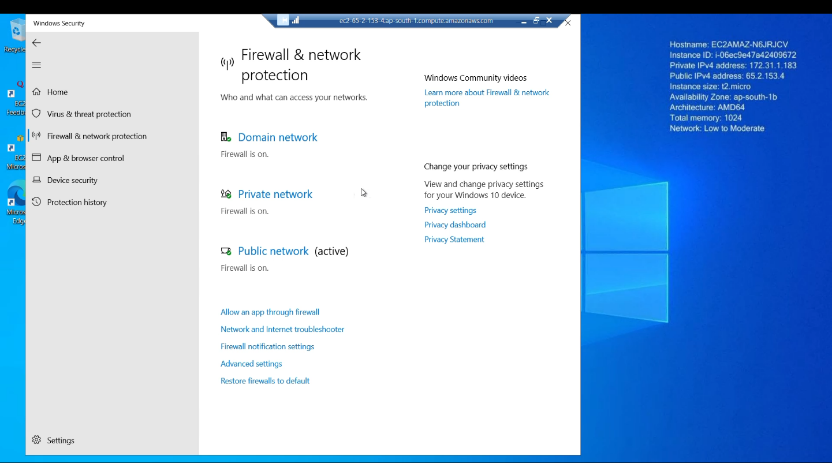

**21. Select advanced setting option and the Windows defender firewall properties.**

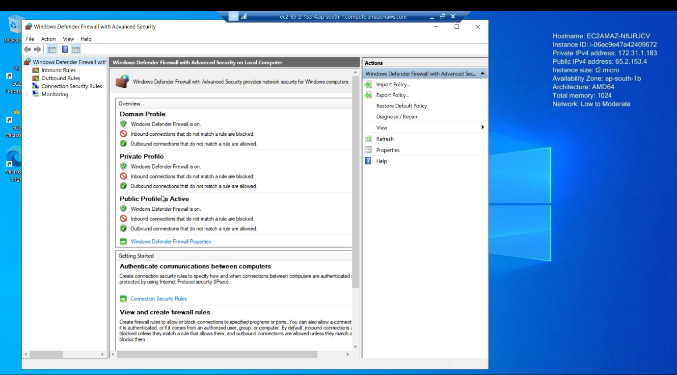

**22.Now select public profile and change inbound connection mode to allow and apply changes and click OK.**

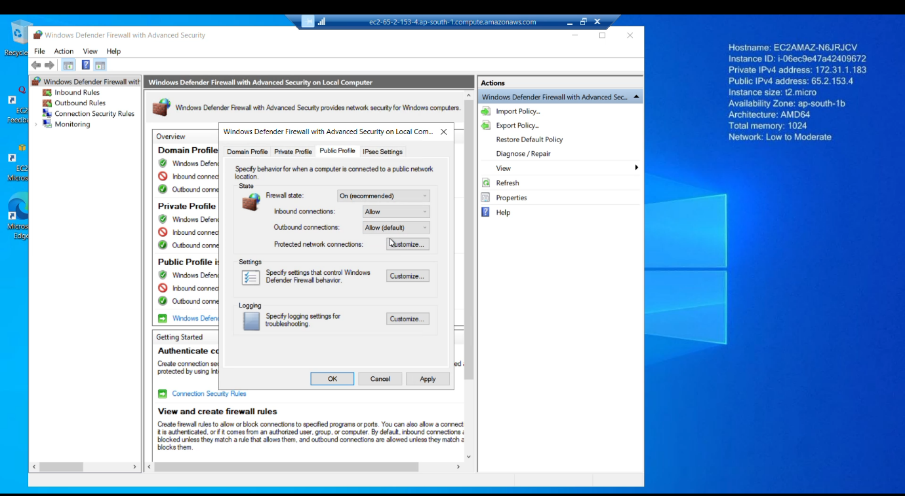

**23.Now open browser and search for XAMPP and download the server on the device.**

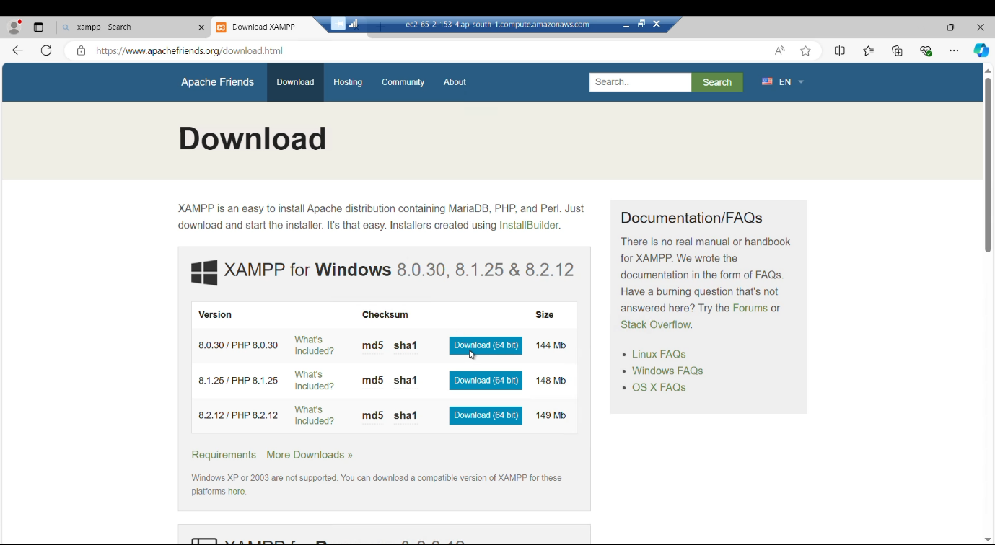

**24.Install the XAMPP server and after installing the XAMPP control panel will open start the apache and mysql server in panel.**

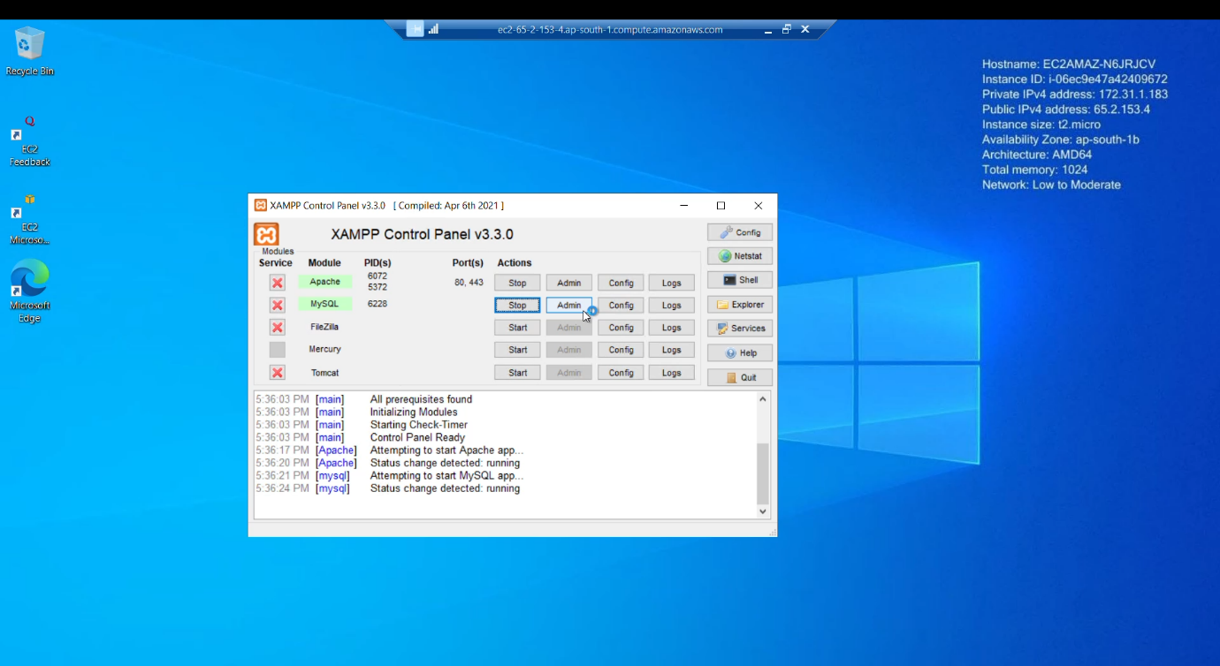

**25. Copy the program files and paste in on the htdocs folder inside the XAMPP folder.**

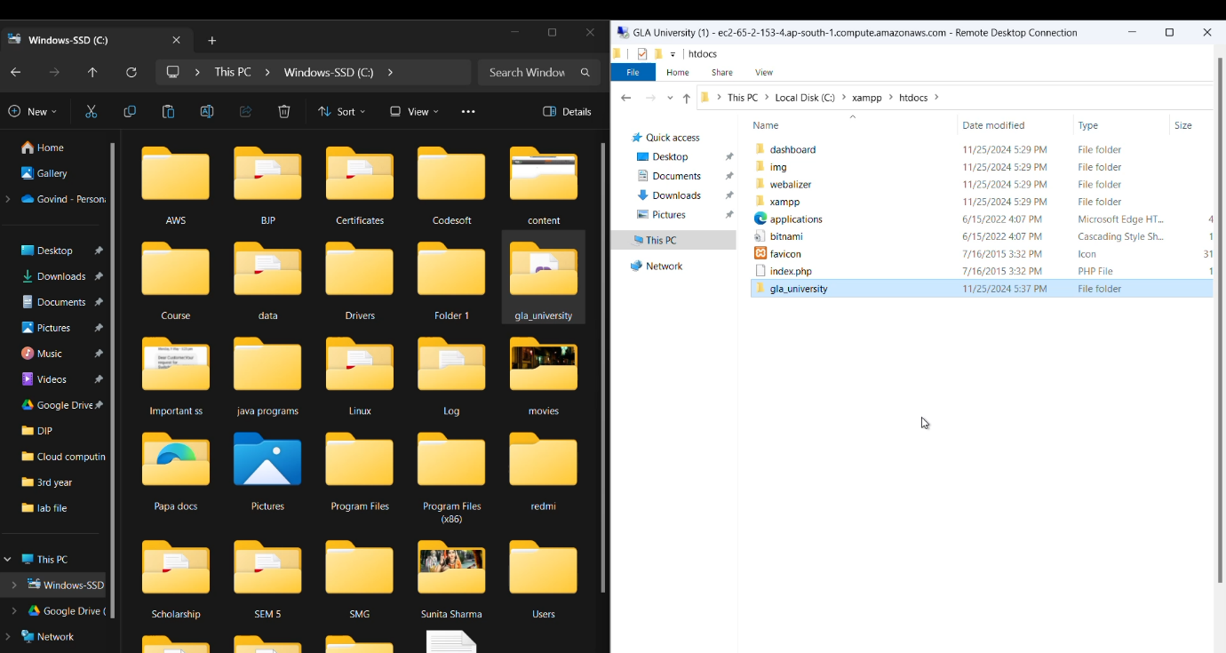

**26. Now open the phpMyAdmin window by entering the given address** [**http://localhost/phpmyadmin/**](http://localhost/phpmyadmin/) **in the browser window.**

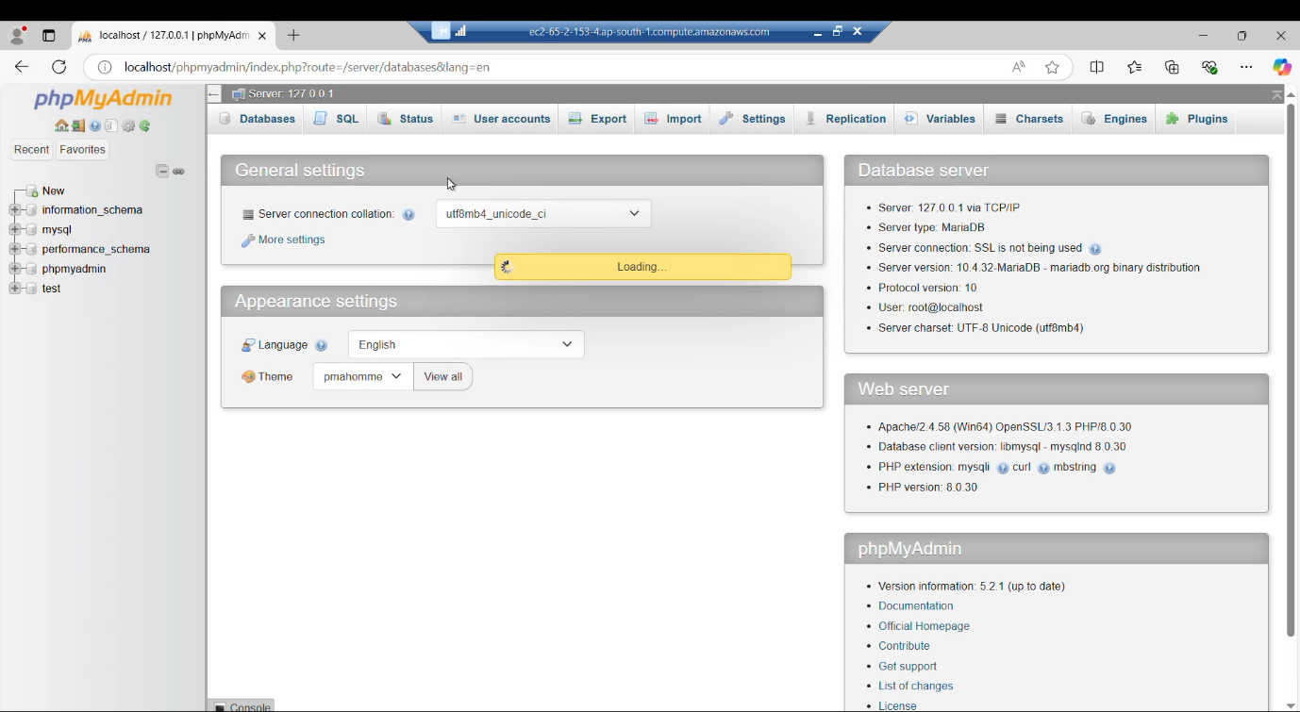

**26.Select databases option and create a new database named as university_db.**

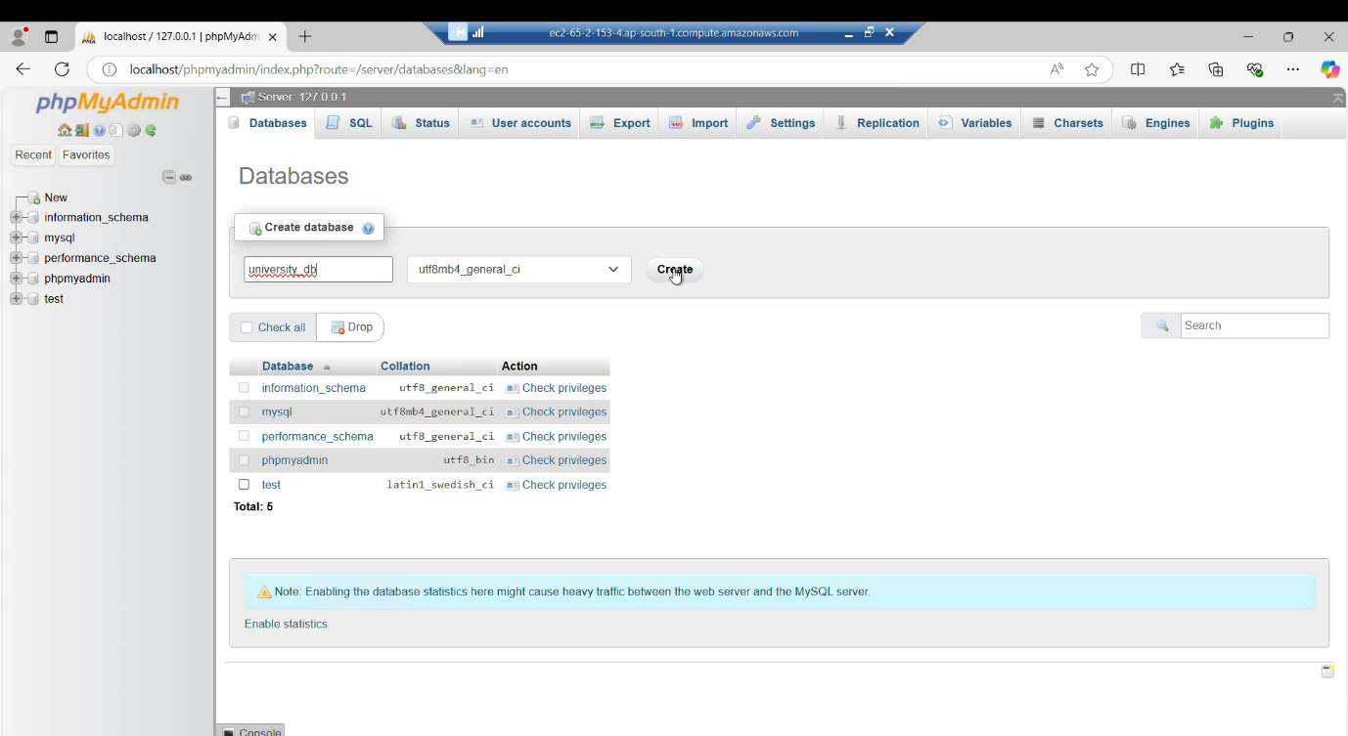

**27. Select the database university_db and selects the query option.**

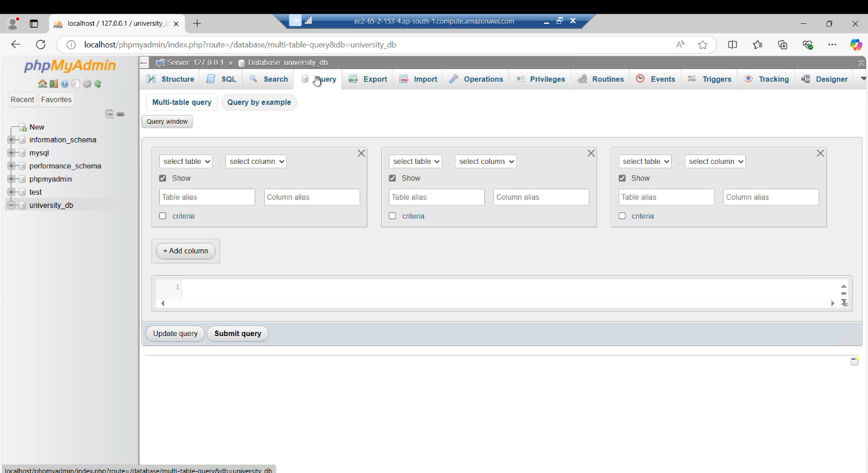

**28. Enter the sql commands in the query section and click on submit query option. The database for admission queries is created.**

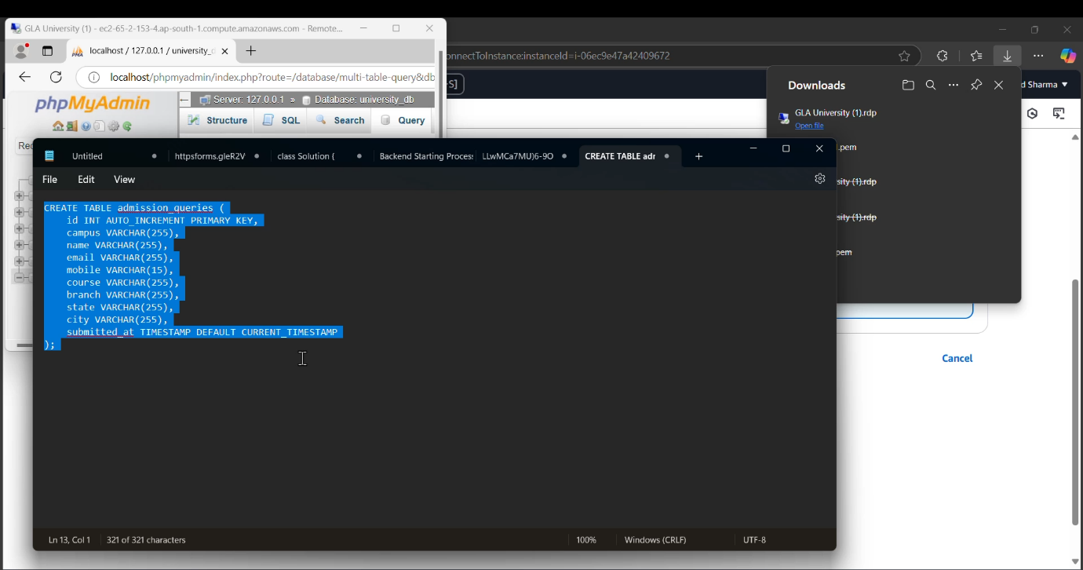

**29. The procedure for hosting the website is completed.To view the results go to aws console and select the instance Gla university and click on open address as shown below-**

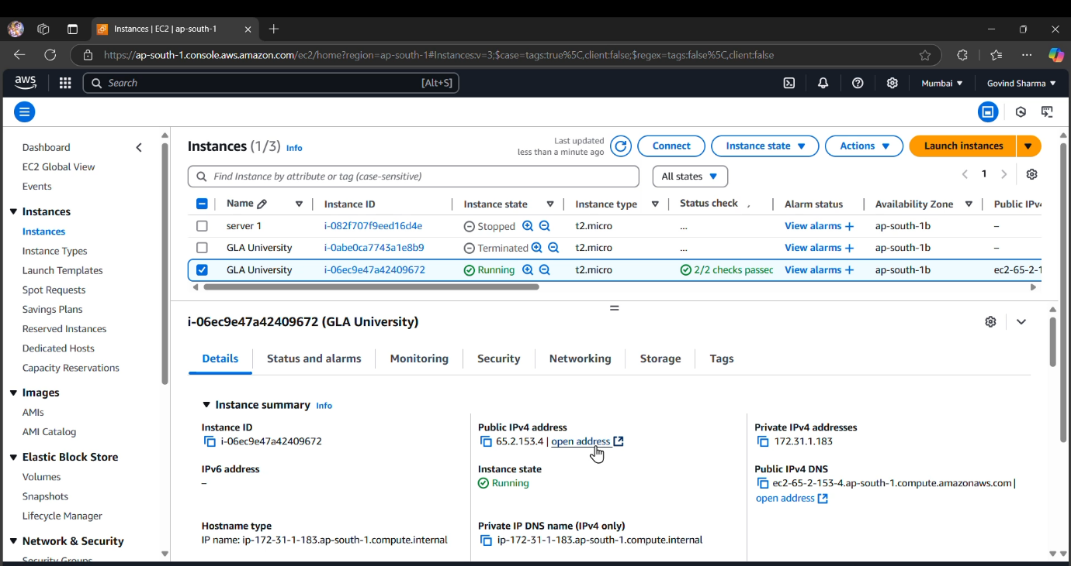

***RESULTS:-***

**1.**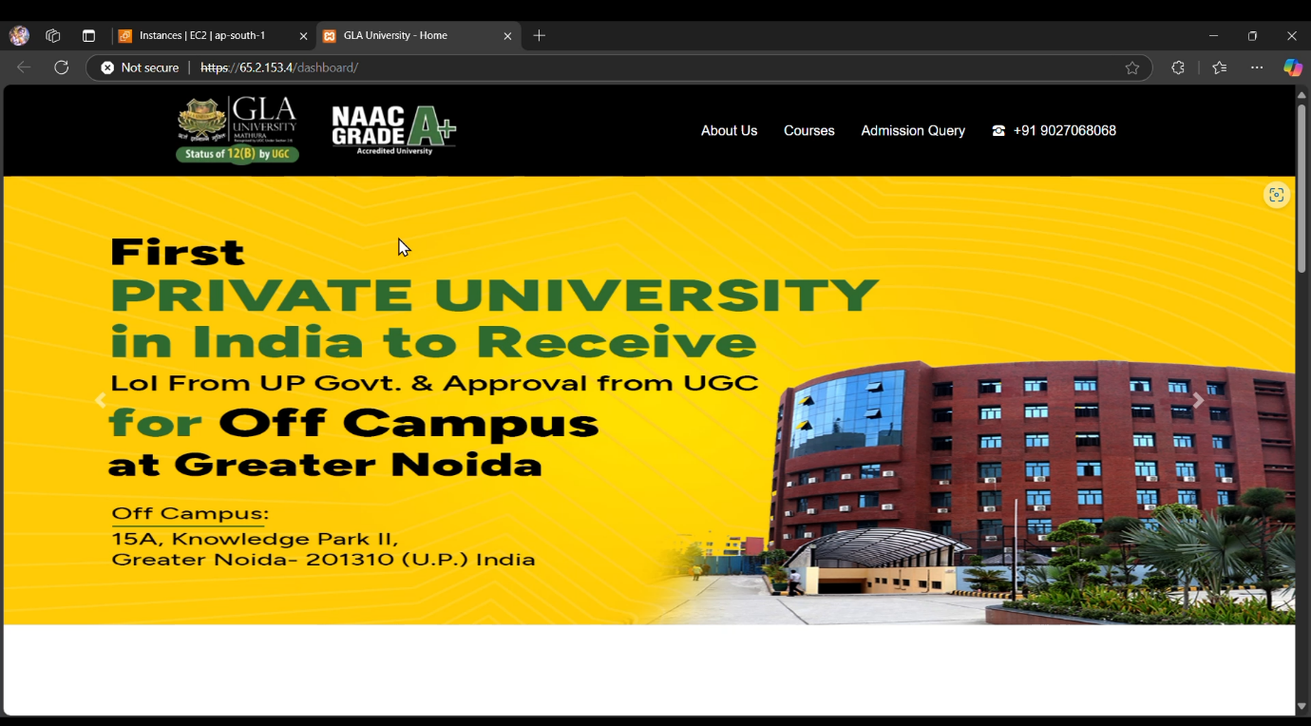

**2.**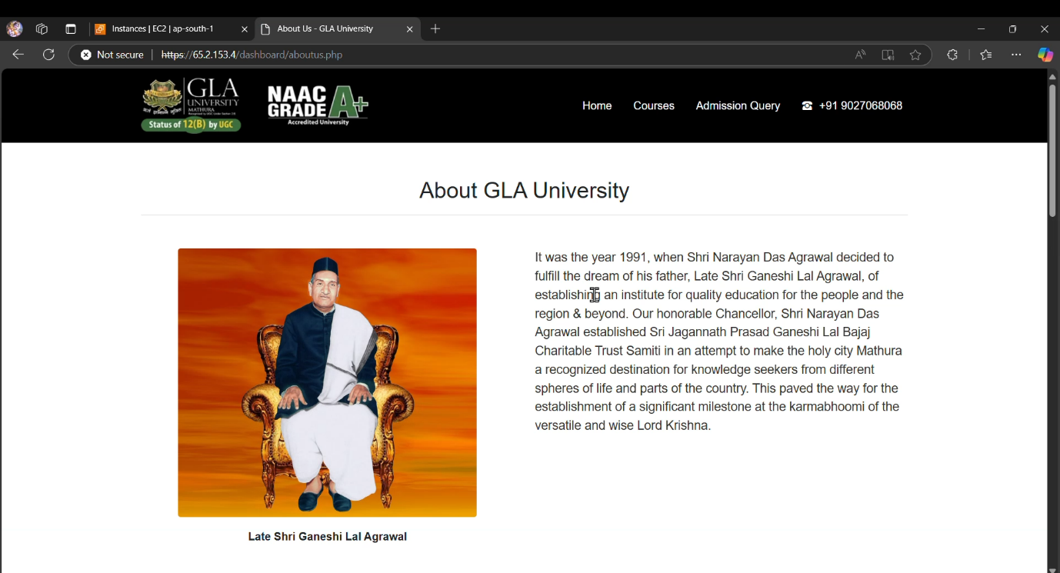

**3.**

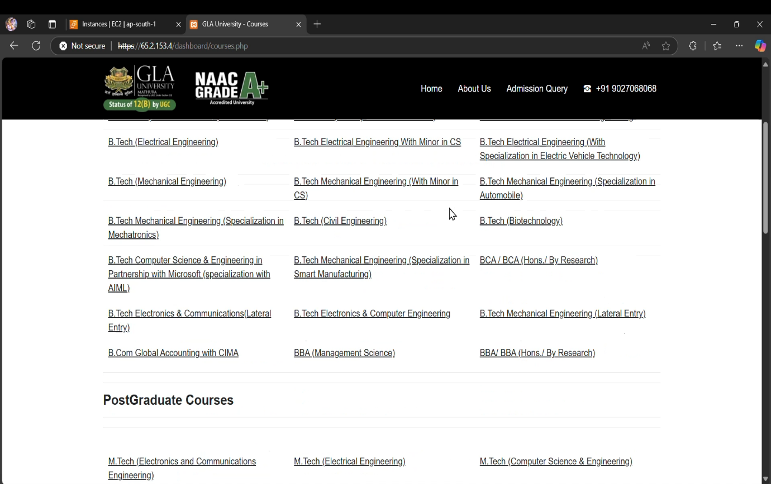

**4.**

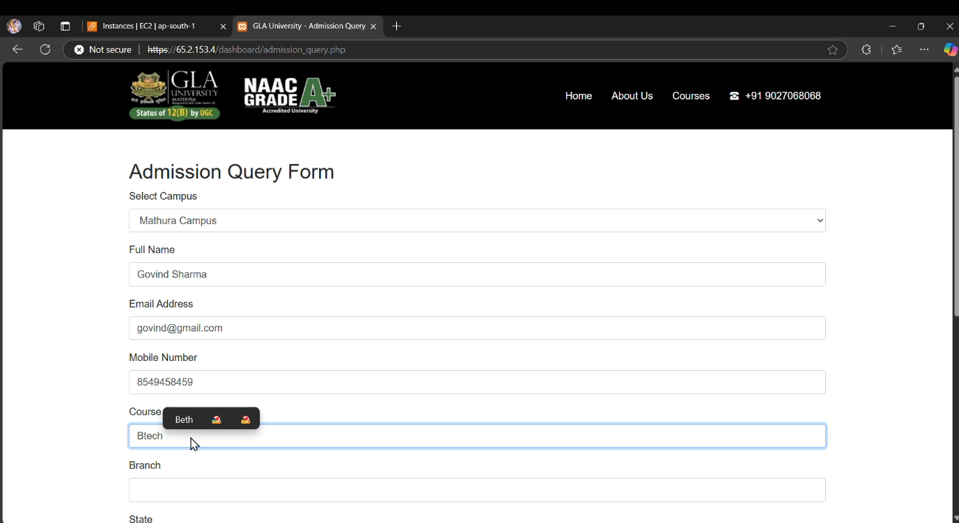

**5.**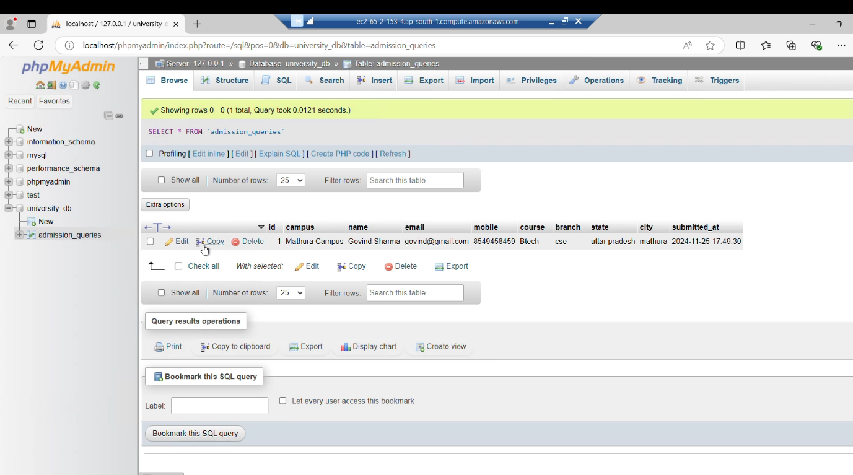

* **Here is the drive link of the recorded tutorial of the whole project-**

https://drive.google.com/file/d/1Lcl6Dw91kEC7ApHFps02jfv93ebOigsC/view?usp=drive_link

***Conclusion:-***

Conclusion of PHP Website Hosting Project on AWS Cloud

In this project, we successfully deployed a dynamic PHP website on the AWS Cloud using an EC2 instance, showcasing the effective integration of various web development technologies, including PHP, HTML, CSS, JavaScript, and MySQL for database management. The process involved several key steps that highlighted best practices in cloud computing and web development.

This project not only demonstrated the technical capabilities required to deploy a PHP website on AWS but also provided valuable insights into the challenges and best practices of cloud hosting. The experience gained in configuring servers, managing databases, and developing dynamic web applications has equipped us with the skills to tackle more complex projects in the future.

By leveraging cloud technology, we have ensured that our website is scalable, reliable, and accessible to users around the globe, fulfilling the project’s objectives and laying the groundwork for future enhancements.